THE FRACTIONAL KNAPSACK PROBLEM
- We are given ‘n’ items and a knapsack.
- The item ‘i’ has a weight w_{i} and a profit p_{i} the knapsack has a capacity ‘M’.
- We are also allowed to take an item in fractional part.
- If a fraction x_{i}, 0 ≤ x_{i} ≤1 of item i is placed into the knapsack then a profit of pi xi is earned.
- The objective is to fill the knapsack that maximizes the total profit earned.
- The i^{th} item contributes the weight w_{i .}x_{i} to the total weight in the knapsack and profit p_{i} .x_{i} to the total profit.
- The problem is stated as:

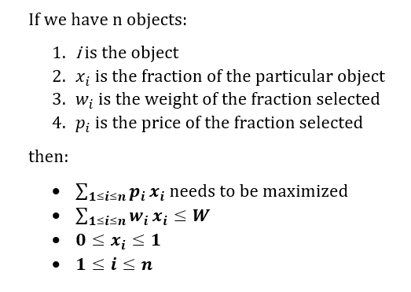
A feasible solution will satisfy equations 2,3,4 but an optimal solution will satisfy equation 1
Algorithm

- If the items are already been sorted into non-increasing order of
p[i] /w[i] then the algorithm given below obtains solutions corresponding to this strategy.
Algorithm GreedyKnapsack (m, n)
// P[1 : n] and w[1 : n] contain the profits and weights respectively of items ordered so that p[i] / w[i] > p[i + 1] / w[i + 1].
// m is the knapsack size and x[1: n] is the solution vector.
{
for i := 1 to n do x[i] := 0.0 // initialize x
U := m;
for i := 1 to n do
{
if (w[i] > U) then break;
x [i] := 1.0; U := U – w[i];
}
if (i < n) then x[i] := U / w[i];
}

Algorithm: Greedy-Fractional-Knapsack (w[1..n], p[1..n], W)
for i = 1 to n
do x[i] = 0
weight = 0
for i = 1 to n
if weight + w[i] ≤ W then
x[i] = 1
weight = weight + w[i]
else
x[i] = (W - weight) / w[i]
weight = W
break
return x

Example:

- Consider the following instance of the knapsack problem: n = 3, m = 20, (P1, P2, P3) = (25, 24, 15) and (W1, W2, W3) = (18, 15, 10).
Item-1
Profit=25-p1
Weight=18-w1
P1/w1=25/18=1.38
Item-2
P2=24
W2=15
P2/w2=24/15=1.66
Item=3
P3=15
W3=10
P3/w3=15/10=1.5

- Find out the optimal solution for the following 3 items (P1, P2, P3) = (500,900,700) and (W1, W2, W3) = (1, 3, 7). Knapsack capacity is 5.

item | Profit(pi) | Weight(wi) | Pi/wi
2 | 24 | 15 | 1.6
3 | 15 | 10 | 1.5
1 | 25 | 18 | 1.38

Solution={0,0,0}
Item2 will be selected (maximum Pi/Wi)
Weight of item 2 is 15
Capacity=20
Solution={0,1,0}
Remaining capacity=20-15=5
Item 3 is next item to be selected
Weight =10
Item 3(fraction) = 5/10=1/2=.5
Solution={0,1,1/2)
Remaining capacity=0
Profit=sum of PiXi=0*25+1*24+.5*15=0+24+7.5=31.5

Example
Let us consider that the capacity of the knapsack W = 60 and the list of provided items are shown in the following table −
Item | A | B | C | D
Profit | 280 | 100 | 120 | 120
Weight | 40 | 10 | 20 | 24
Ratio (Pi / Wi) | 7 | 10 | 6 | 5

After sorting, the items are as shown in the following table.
Item | B | A | C | D
Profit | 100 | 280 | 120 | 120
Weight | 10 | 40 | 20 | 24
Ratio (pi/wi) | 10 | 7 | 6 | 5

Solution set={0,0,0,0}
Item B is selected first
Weight=10
Profit=100
10<60=B is selected
Solution = {0,1,0,0}
Remaining Capacity=60-10=50
Item A is selected
Weight=40
Profit=280
40<50=A is selected
Solution={1,1,0,0}
Remaining capacity =50-40=10
Item C is selected
Weight=20
Profit=120
20>10=item c (fraction) can be selected=10/20=1/2
Solution={1,1,1/2,0}
Remaining capacity=10-10=0
∑P_{i}X_{i=}P1x1+p2+x2+p3x3=1*280+1*100+1/2*120+0*120=280+100+60=440

